[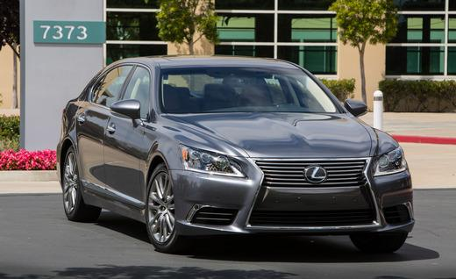](http://www.caranddriver.com/photos-12q3/467631/2013-lexus-ls460-photo-468860)